MongoDB

Installing MongoDB
Before we begin we need to update your system. For this let’s use the following commands.
sudo apt-get update
sudo apt-get upgrade

Usually, ubuntu’s official package repositories holds the up-to-date version of the MongoDB. So we can install the necessary packages using apt itself.
The following command actually installs several packages of the stable version of MongoDB, along with some management tools for the MongoDB server.
sudo apt install -y mongodb

The mongoDb has installed successfully. Let’s verify whether the service has started.
The following command is used to check the service’s status.
sudo systemctl status mongodb
We can also verify this further by actually connecting it to the database server and executing a diagnostic command. For this let’s use the following command.
mongo --eval 'db.runCommand({ connectionStatus: 1 })'
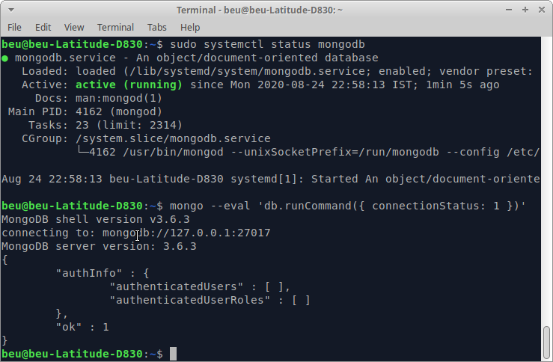
From the above output, the MongoDB server is up and running according to the systemd.
Also, the command which connected the database outputs the current database version, the server address and port, and also the output of the status command.

Since MongoDB has installed as a systemd service, we can actually manage it using standard systemd commands even along all the other system services in Ubuntu.

To start the server, let’s use sudo systemctl start mongodb command.
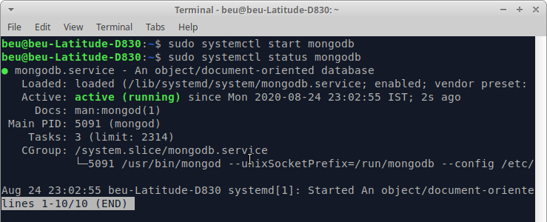
Similarly, to stop the server, let’s use sudo systemctl stop mongodb command.
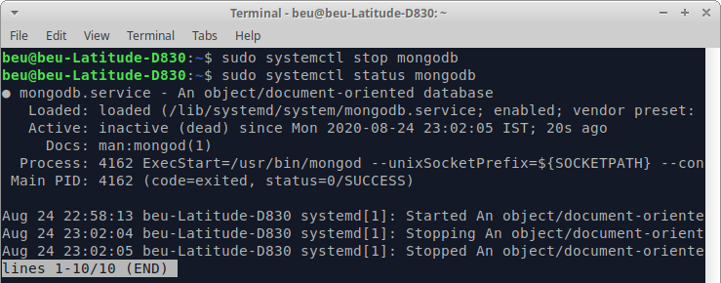
We can also restart the server using a command, sudo systemctl restart mongodb.
To verify the status of the service: sudo systemctl status mongodb

Creating a MongoDB Database
Lets open the MongoDB shell in a terminal window using the mongo command.
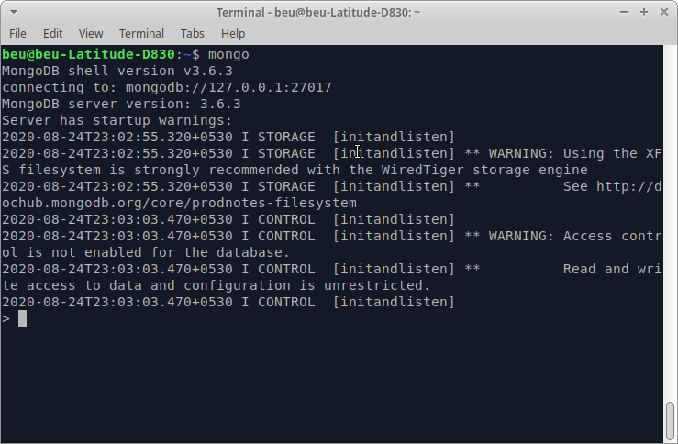
MongoDB use command is used to create database. The command will actually creates a new database if it doesn't exist, else it will simply return the existing database.
use myDatabase - creating the database
db - to check the currently connected database
show dbs - to list down all the databases

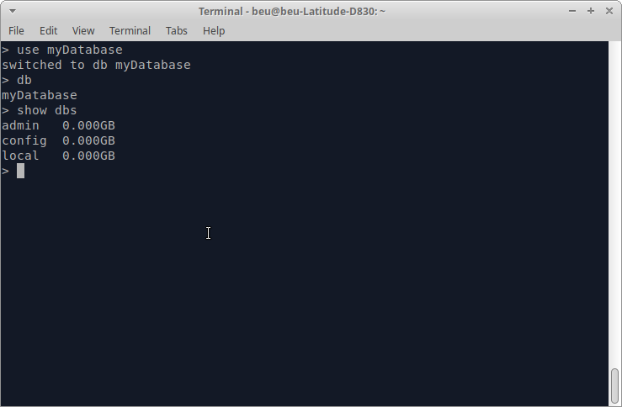
Deleting the MongoDB Database
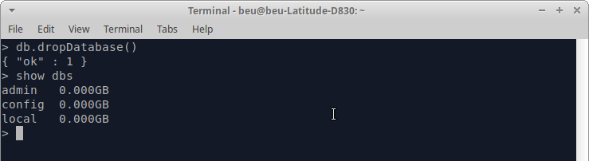
MongoDB db.dropDatabase() command is used to drop a existing selected current database.

